**Project Design Phase-II**

**Technology Stack (Architecture & Stack)**

|  |  |
| --- | --- |
| Date | 03 October 2022 |
| Team ID | PNT2022TMID10208 |
| Project Name | Protection – Protection and pursuing IOT – based smart device for child safety |
| Maximum Marks | 4 Marks |

**Technical Architecture:**

The Deliverable shall include the architectural diagram as below and the information as per the table1 & table 2

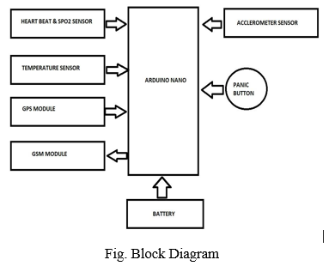

|  |  |  |  |
| --- | --- | --- | --- |
| **S.No** | **Component** | **Description** | **Technology** |
|  | Gate Way | An IoT gateway is a centralized hub that connects IoT devices and sensors to cloud-based computing and data processing | TCP IP protocol |
|  | Temperature Sensor | The temperature and wetness sensor detects the temperature and wetness of the baby and if it increases a particular level, the message will be sent to the parents | Infrared (IR) sensors |
|  | Touch sensor | The NEO 6M GPS is used as the basis for a complete GPS module.The wearable device's GPS position sensor sends accurate latitude and longitude coordinates to the registered smartphone | capacitive |
|  | Heart Sensor | Maxim's MAX30100 integrated pulse oximetry and a heart-rate sensor. It's an optical sensor that measures the absorbance of pulsating blood through a photodetector after emitting two wavelengths of light from two LEDs. A low-noise analogue signal processing device processes the signal | photo plethysmograph (PPG) |
|  | GSM module | The Global System for Mobile Communications module is intended for SMS monitoring,used to perform practically connect to the internet via GPRS,When the panic button is touched message is sent to the registered phone, coupled with a phone call and a live GPS location | standard-based Low Power Wide Area |
|  | GPS Location Sensor | It includes GPS location sensor which determines the location of the child wearing the safety device in real time and sends this to the Arduino UNO. | Global Navigation Satellite System (GNSS) Network |
|  | Serial Camera | the surrounding image in SD card which is captured by the serial camera. This captured image is sent as MMS to the parent/caretaker mobile. | CSI (camera serial interface) |
|  | SOS Light | SOS light which alerts the nearby people about the child in distress by flashing the universal light symbol on the device and the alarm helps the parents to locate the child or children when they get separated from their parents by sounding a loud alarm. | Sensor Observation Service (SOS) |

**Table-2: Application Characteristics:**

| **S.No** | **Characteristics** | **Description** | **Technology** |
| --- | --- | --- | --- |
|  | Real-time location | IoT-Enabled child location tracking solutions use GPS and mobile data to allow parents or guardians to monitor and communicate with children remotely. Child monitoring solutions can be attached to a child, via their clothing or backpack, or can be worn around the wrist, resembling a smartwatch. | Global Navigation Satellite System (GNSS) Network |
|  | Gadget Plug and Unplug Monitoring | This feature is to keep monitoring if the safety gadget is plugged or not by monitoring the contact switch, necessary alerts are provided on parental app whenever the device is unplugged. | Chrome |
|  | Stay Connected Feature | Stay connected feature is used to trigger call and pre-defined SMS anytime from gadget to parental phone by just pressing a button and also parent can make SMS and call to the gadget anytime | Technology Used |
|  | Distress alarm buzzer for the child. | If a child is separated from his./her parents. The parent can locate the child by sound in a very loud alarm on alarm on the wearable. To achieve this, a piezoelectric buzzer is used which is for emitting a strong tone “BUZZ”. | a piezoelectric buzzer |
|  | Power Supply | The power supply cable charges the IoT device or provides battery to all the devices then only they will work properly can get accurate values and last for more days. | Sensor Observation Service (SOS) |